

**CST 2120**

**Web Applications and Databases**

**GAMING WEBSITE**

**Coursework 1**

Uzma Shaikh

M00738037

BSC Information Technology

Second year

Table of Contents

**ABOUT THE GAME** 3

**WEBSITE DESCRIPTION** 5

• Home Page 5

• Highscores Page 5

• Register Page 5

• Login Page 5

SCREENSHOTS 6

• **Home Page of the website** 6

• **Highscores page of the website** 7

• **Register page of the website** 8

• **Login Page of the website** 9

Problems encountered 10

Conclusion 10

KUNG FU ADVENTURE

# **ABOUT THE GAME**

Kung Fu Adventure is a 2D single-player game. This game is inspired by the animated movie series Kung Fu Panda. In the game, the player has to help Po-the Kung Fu Warrior in his journey home by saving it from the evil Warrior Tai Lung.

This includes jumping over the sharp objects. At the same time, feeding Po his favorite dumplings and collecting the magic chi earns bonus points. Po’s journey is endless so travel as far as possible to achieve the highest score!



**Magic Chi**

**Dumplings**

**Obstacles**

**HOW TO PLAY**

Kung Fu Adventure is a game that is played using keys displayed on the screen. The graphics in the game are obtained from online sources. The keys are: Play, End game and Jump respectively. The ‘PLAY’ button starts the game, the ‘END GAME’ button ends the game and the ‘JUMP’ button helps the character jump. The objective of this game is to pass through as many obstacles as possible.

The obstacles are semi-circular saws that appear in a loop. Collecting the dumplings gives the player 20 extra points. Collecting the magic chi gives the player 30 extra points, whereas touching an obstacle ends the game. When the player loses, his/her score is shown and displayed in the Highscores page.

****Make sure you achieve the highest score to get your name displayed at the top of the ranks! This game is a Spin-off to the offline chrome T-rex Dino game.

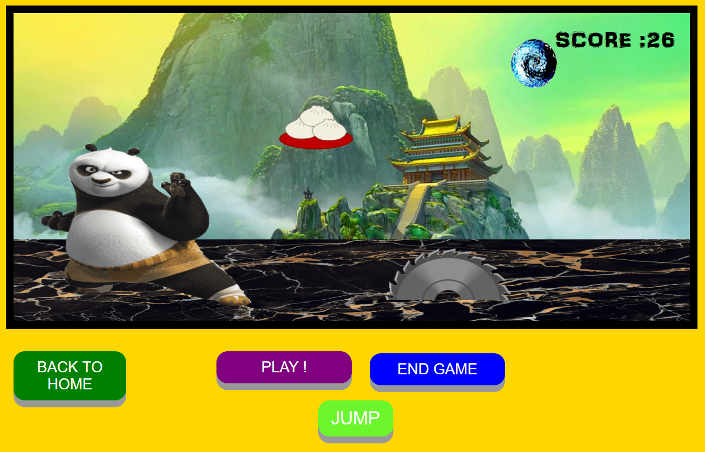

On clicking the Triangular PLAY button, the player is brought to the game page where he/she can play and replay the game endlessly.

# **WEBSITE DESCRIPTION**

RelicGames is a Gaming website containing the following pages: Home, Highscores, Register, and Login respectively.

## Home Page

It contains the website logo, a navigation bar which takes the user to different pages in the website and a footer. It also consists of the ‘PLAY’ button which transports the user to the page containing only the game. This is where the user plays the game and his score is displayed and stored.

Additionally, the Home Page comprises of the description/instructions by which the game is played along with the walkthrough video, which shows the user a demo of the game being played.

## Highscores Page

It consists of the website logo, a navigation bar which takes the user to different pages in the website and a footer. It also contains a list of users and their scores they have gained while playing the game.

## Register Page

It contains the website logo, a navigation bar which takes the user to different pages in the website and a footer. It consists of the registration form which the user needs to fill to create an account in the website.

The user is required to enter an Email ID, his/her date of birth, a username, a password and confirm the password. After this, they can click the CHECK button to verify if all fields are filled. If ‘Please ensure all fields are filled’ is displayed, this means a field is empty. If the message displays ‘You can now register yourself’ then they can proceed to register themselves by clicking the REGISTER button. Once they have registered, ’Congratulations! You are successfully registered’ is displayed. If both the passwords are not the same, ‘The passwords do not match’ is displayed.

The user can delete his/her account by entering their correct Email and Password and clicking the DELETE USER button. On doing this, a message like ‘The user is deleted’ is displayed. If the user doesn’t enter the correct password, ‘The user cannot be removed, wrong password’ is displayed. If all the details are wrong, ‘No such user exists!’ is displayed.

It also comprises of the CLEAR button which clears the local Storage and a CANCEL button which clears the fields.

## Login Page

It consists of the website logo, a navigation bar which takes the user to different pages in the website and a footer. It enables users to access their existing account by entering their username, password and clicking the ‘PLAY NOW >>’ button. If the user doesn’t have an account, the page contains a link that proceeds the user to the Register page. If the user enters the wrong Password. ‘The password is incorrect’ is displayed. If the user enters wrong Email ID and Password, ‘No such registered user exists’ is displayed. When the user clicks the ‘SIGN OUT’ button, ‘you have successfully logged out’ is displayed.

# SCREENSHOTS

## **Home Page of the website**

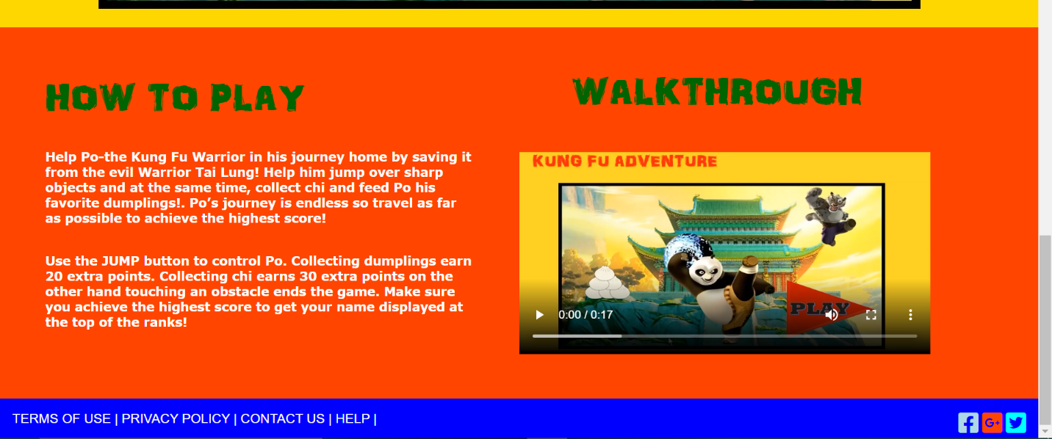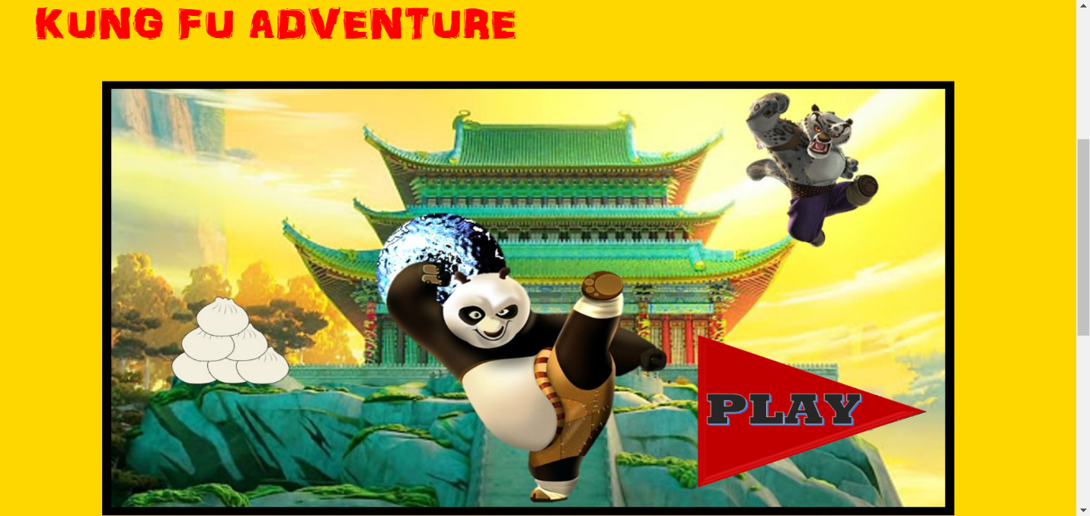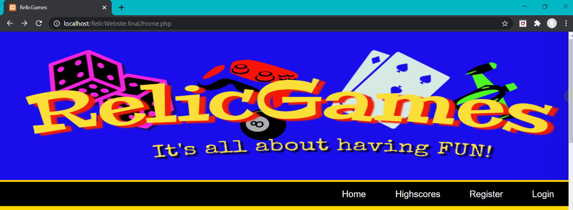

## **Highscores page of the website**

## **Register page of the website**

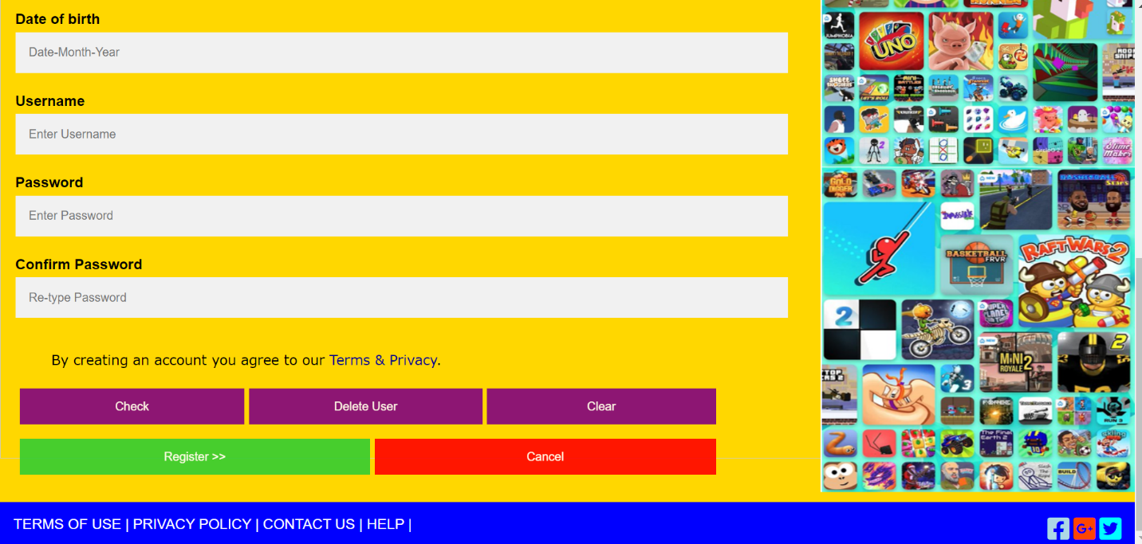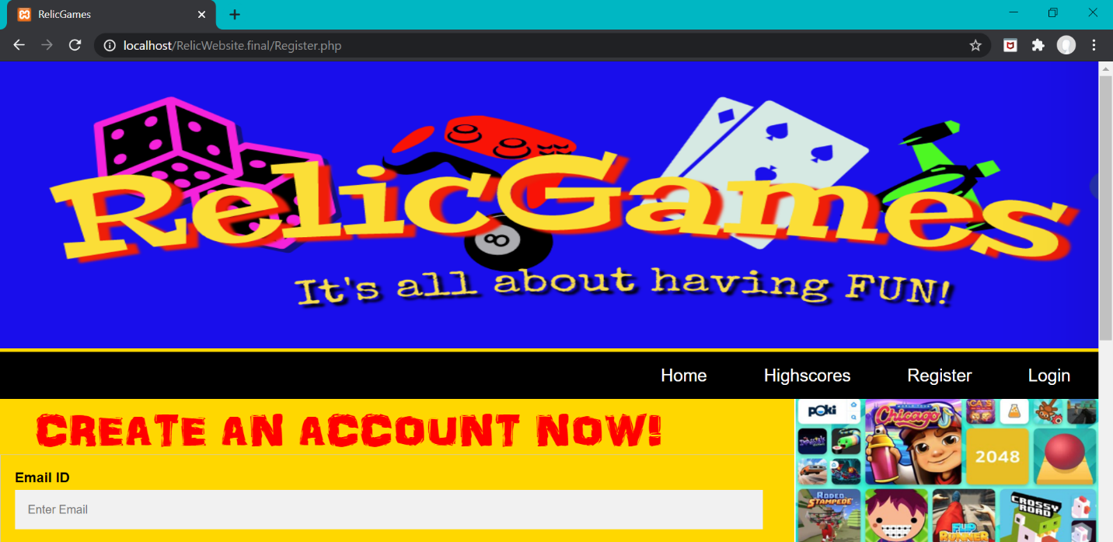

## **Login Page of the website**

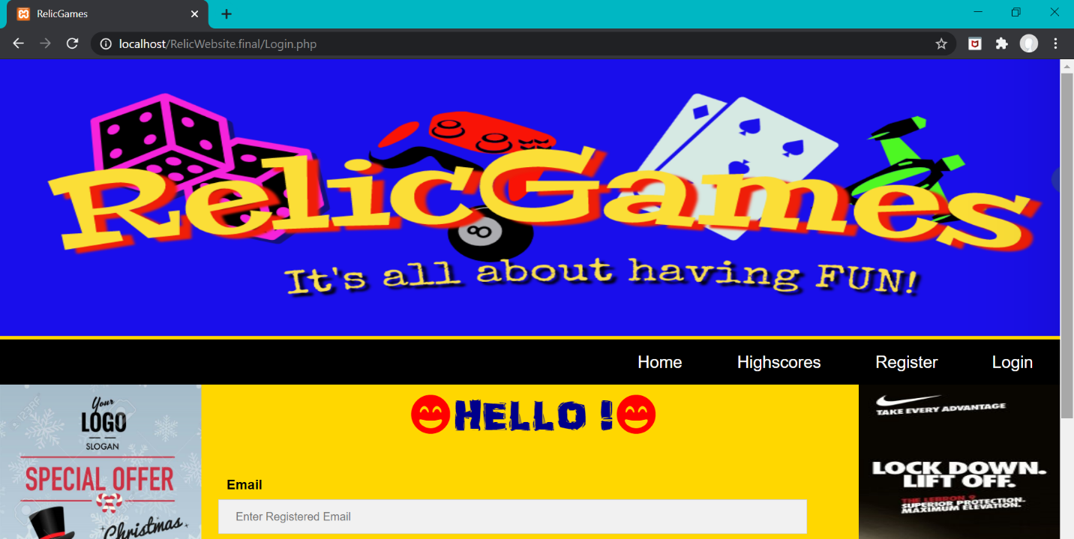

# Problems encountered

While working on this coursework, I faced few problems because of missing semi-colons, missing brackets and unclosed strings. This was resolved by the software like Visual Studios. I also faced problems while working with PHP and Local Storage, this was solved by going through the lecture videos and attending classes. Spending time and continuous effort is also an important factor for identifying problems.

# Conclusion

This coursework helped me gain knowledge about many applications and reflect them. Visual Studio and Brackets provided a strong base for my coding as they helped me easily identify the problems. Building wireframes, working with PHP, JavaScript, HTML, JSON and CSS has been very educative. I can now use this knowledge for building more websites and games in the future.

The entire process of building the website and game helped me learn about my mistakes and resolve them. I am very grateful to have been given this wonderful opportunity.